**Q. Write a Problem Analysis Chart (PAC), Algorithm and Flowchart for calculating the average runs of a batsman for 4 matches.**

PAC

|  |  |  |  |
| --- | --- | --- | --- |
| **Data** | **Processing** | **Output** | **Solution Alternatives** |
| Runs 1,  Runs2,  Runs3,  Runs4 | Total Runs = Runs1 +Runs2 + Runs3 + Runs4  Average Runs = Total Runs/ 4 | Print Average Runs |  |

Algorithm

* Start
* Use variable **Runs1**, **Runs2**, **Runs3**, **Runs4**, **Total_Runs**, **Average_Runs**
* Read **Runs1**, **Runs2**, **Runs3**, **Runs4**
* Calculate **Total_Runs** = **Runs1** + **Runs2** + **Runs3** + **Runs4**
* Calculate **Average_Runs** = **Total_Runs** / 4
* Print **Average_Runs**
* Stop

Flowchart

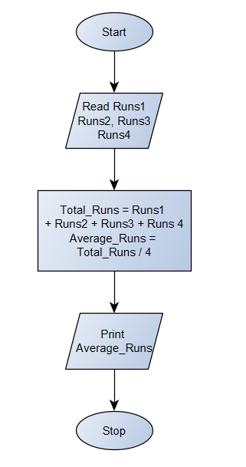

Python Program

print(**"Enter the runs scored by the batsman in the 4 matches :"**)  
Runs1 = int(input(**"Runs scored in 1st Match - "**))  
Runs2 = int(input(**"Runs scored in 2nd Match - "**))  
Runs3 = int(input(**"Runs scored in 3rd Match - "**))  
Runs4 = int(input(**"Runs scored in 4th Match - "**))  
Total_Runs = Runs1 + Runs2 + Runs3 + Runs4  
Average_Runs = Total_Runs / 4  
print(**"The Total runs scored by the batsman in all the four matches ="**, Total_Runs)  
print(**"The Average runs in the four matches ="**, Average_Runs)